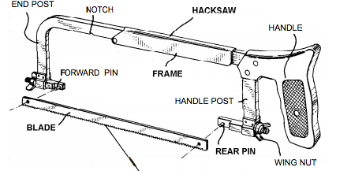

Hacksaws
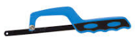
Note: The teeth point forward. Apply forward pressure when cutting (not downward pressure). Move your body and not just your arms when you cut. Apply pressure on the forward stroke. Release pressure on the return stroke. Applying pressure on the return stroke with dull the blade.
Close Quarter Hacksaw
Cut at about 50 strokes per minute. Make a long steady stroke using the whole length of the blade.
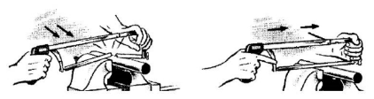

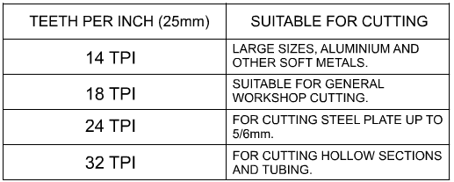
PITCH:
The distance between each tooth is called the pitch. An 18 teeth blade means 18 TPI (teeth per inch).
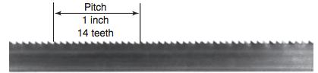
14 TPI is coarse while a blade with 32 TPI is very fine.

Choose a blade as coarse as possible to provide plenty of chip clearance but you must be able to fit at least 3 teeth (minimum) on the material so the blade doesn’t jam.
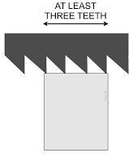
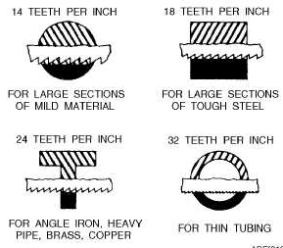

The thickness and hardness of the work piece are the two things that determine the blade to use.
- Use a coarse blade on soft material.
- Use a fine tooth blade on hard material.

Blades are characterized by the location of the teeth called the set. It refers to the location/bending of the teeth.
- The Straight/Altered set has one tooth bent to the left and the next one bent to the right.
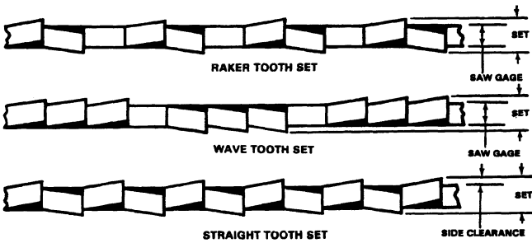
- The Wavy set has several teeth bent left and then several teeth bent right.
- A Wavy set is found on most fine tooth blades.
- A Raker set has a neutral tooth and then one bent left and one bent right.

Two types of hacksaw blade are generally available:
- High Carbon Steel blades are used for general cutting/sawing. They do not last as long a High Speed Steel blades.
- High Speed Steel blades are much more expensive but keep their cutting edge for longer and are suitable for cutting hard materials such as stainless steel and alloys.
- Bi-metal blades – they have hardened teeth to stay sharp and the rest of the blade is made of a more flexible metal.

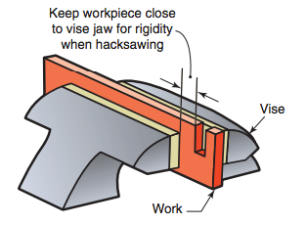
General Information:
- Tighten the blade until it is snug (not tight).
- Always mount your work in the vise to the cut line is close to the jaws (12 mm or ½ inch)
- Place the blade on the work just outside the marked line (on the waste side). Cutting vertically can help make the cut straight and it is easier to follow the line.
- Use a v-shaped file to get a start mark if the hacksaw won’t stay on the line.
- Clamp thin metal (sheet metal) between two thin pieces of wood for a better cut.
- By turning the blade at right angles to the frame, you can continue a cut that is deeper than the capacity of the frame.
- The cut is called the kerf.
- Don’t use a new blade in a partially cut hole. The old blade would be worn thinner so the new blade will bind in the kerf. Instead, flip the material and start cutting from the other side to let the two kerfs meet.
- A drop of cutting oil can help for difficult cuts.

Review Questions:
1. What is the kerf?

2. What is the set on a saw blade?

3. What is the pitch of the hacksaw blade?

4. What determines the selection of a saw blade for a job?

5. Hand hacksaw blades are categorized in several ways. What are they?

6. What speed should be used in hand hacksawing?

7. Give four causes that make saw blades dull.

8. Give two reasons why hacksaw blades break.

9. A new hacksaw blade should not be used in a cut started with a blade that has been used. Why?

